

Course 61998: Extended Project in Software Engineering

**Capstone Project Phase A**

**24-1-R-16**

**NutriSmart: A Personalized Recipe App for Optimal Health**

Students:

Khalid Sweid-324264530 Khalidsw02@gmail.com

Inbar Mizrahi-316582709 Inbar1289@gmail.com

Supervisor:

Dr. Natali Levi

**Table Of Contents**

**Abstract 3**

**1.Introduction 3**

**1.1 The Current Gap in Nutrition Solutions 4**

**2. Related Work 5**

2.1 Protein definition 6

2.1.1 Protein intake from different diets 6

2.1.2 The risk of protein consumption 7

2.2 Personal Nutrition 7

2.3 Technology- pros and cons 8

2.4 Chat GPT 8

2.4.1 AI in nutrition apps 9

2.4.2 Ethical and other concerns regarding the use of AI in nutrition 9

2.5 Dietary assessment with the use of food images recognition techniques 10

2.5.1 Food Detection and Recognition Using Convolutional Neural Network 10

2.5.1.1 Food recognition 11

2.5.1.2 Food detection 12

**3. Expected Results/Achievements 12**

**4. Challenges 13**

**5. Research /Engineering Process 14**

5.1 Research - Nutrition & Nutrition applications 14

5.2 Research - AI and ChatGPT: 14

5.3 Our process approach: 17

**6. Product 18**

6.1 Use Case Diagram 18

6.2 Activity Diagram 19

6.3 Class Diagram 21

**7. Algorithm 22**

**8. Application Screens 25**

**9. Testing Plan 28**

**10. References 33**

# **Abstract**

Achieving diverse and personalized nutrition in the modern era is a challenging endeavor due to the complex interplay of individual factors such as lifestyle, dietary preference, and unique health objectives. Traditional dietary guidelines often fall short in providing tailored solutions, leading to widespread nutritional imbalance and deficiencies. As lifestyles become increasingly diverse and dynamic, the need for a comprehensive and user-centric approach to nutrition has become more evident.

In this context, the NutriSmart app emerges as a groundbreaking solution, leveraging cutting-edge technology to bridge the gap between generic dietary advice and the specific requirements of individuals. This app addresses the challenges posed by generic dietary recommendations and empowers users to make informed choices that not only meet their unique health objectives but also contributes to overall well-being.

In addition, NutriSmart utilizes image recognition technology to analyze meal images that are uploaded, offering customized nutritional data and personalized guidance to assist users in attaining their dietary objectives. This novel characteristic guarantees that consumers receive pragmatic suggestions to improve their meals and bolster their pursuit of good health.

The NutriSmart app stands at the forefront of a new era in nutrition, where personalization and diversity are no longer elusive goals but practical, achievable outcomes.

# **1.Introduction**

In a time characterized by unparalleled technical progress and a swiftly changing global environment, the quest for a healthy and well-rounded lifestyle has become more complex. Contemporary individuals face the difficulties of a rapidly moving lifestyle, varied food tastes, and the continuous influx of generic nutritional guidance that frequently overlooks specific health goals. Attaining a wide range of customized nutrition has become a challenging objective, necessitating a sophisticated comprehension of individual variables, state-of-the-art technologies, and inventive remedies.

In order to tackle these difficulties, our system utilizes sophisticated technologies like Convolutional Neural Networks (CNN) integrated into pre-existing machine-learning frameworks, as well as REST APIs to provide tailored dietary advice. Our technology allows users to upload photographs of their meals, which are then analyzed to accurately calculate the nutritional composition, including protein, calories, and other essential components. Users can obtain customized guidance on meal modifications by entering specific nutritional criteria, such as desired protein intake or calorie goal.

The incorporation of picture analysis into personalized nutrition guidance revolutionizes individuals' attitude to their food habits. Our method not only enhances comprehension of the nutritional composition of meals but also gives actionable advice to assist users in achieving their health objectives. Through the utilization of Convolutional Neural Networks (CNN) for picture identification and the integration of Representational State Transfer (REST) APIs to establish a connection with ChatGPT for tailored recommendations, we are developing a comprehensive tool that adjusts to the distinct requirements of each users, thus facilitating the adoption of a healthier and more balanced lifestyle.

## **1.1 The Current Gap in Nutrition Solutions**

Traditional nutrition apps commonly rely on established models and algorithms to provide general dietary guidance. Most traditional apps use algorithms that calculate daily caloric needs based on factors like age, gender, weight, height, and activity level. These calculations often follow standard equations like the Harris-Benedict equation to estimate the Basal Metabolic Rate (BMR), or Resting Metabolic Rate (RMR). Some apps rely on equations and mathematical formulas to calculate the energy needed for maintaining the present body weight, such as the Estimated Energy Requirement (EER) equation, which considers a person’s age, weight, height, and amount of physical activity.

However, these solutions often fall short in addressing the unique needs and preferences of individuals. The limitations lie in their inability to adapt to the dynamic and diverse nature of individual lifestyles, dietary preferences, and health objectives.

**Our proposed model acknowledges and addresses these limitations by:**

* **1. Integrating Contemporary Algorithms:**
  + Our system incorporates state-of-the-art algorithms and mathematical equations, moving beyond traditional models to derive nutritional values from dietary data. This ensures a more accurate and personalized approach to dietary recommendations.
* **2. Dynamic Computation for Personalized Plans:**
  + Leveraging advanced computational techniques, the model dynamically computes optimal dietary plans based on individual user goals. It considers factors such as dietary restrictions, health objectives, and personal preferences to offer tailored solutions.
* **3. Providing Substitutes and Alternatives:**
  + NutriSmart goes beyond generic suggestions by offering suitable substitutes for ingredients, accommodating various dietary preferences without compromising nutritional value. More than that, NutriSmart allows users to modify their nutrition plan, for instance: if a user follows a nutritional plan, and decides to workout, NutriSmart allows the user to add protein for his meals, along with other important nutritional values for trainers. Not to mention instances where the user possesses a specific objective yet lacks knowledge regarding the requisite nutritional parameters to incorporate - such as in the contexts of sports, pregnancy, obesity, menopause, and similar scenarios - a discerning and informed approach to nutritional guidance becomes imperative.

The project document is thoughtfully structured to provide comprehensive insights into the NutriSmart development process. Section 2 delves into the background, elucidating the need for personalized nutrition solutions. Section 3 outlines the anticipated achievements of the NutriSmart app. Section 4 details the engineering process, including the incorporation of cutting-edge algorithms. Finally, Section 5 elaborates on the evaluation and testing process, ensuring the robustness and reliability of the NutriSmart app.

# **2. Related Work**

Nutrition is a critical component of overall health, influencing various aspects of life, from energy levels and cognitive function to disease prevention and management. Numerous studies underscore the profound impact of nutrition on health and well-being. A balanced diet, rich in essential nutrients, is crucial for preventing chronic diseases such as cardiovascular disorders, diabetes, and certain cancers.

For instance, a woman's body during pregnancy goes through several changes, including the thyroid gland. This gland needs a mineral called “iodine” to work properly, which helps make important hormones for the baby’s growth, and brain development.[12] In addition, nutrition is a vital component in bodybuilding and workout. A pertinent challenge confronting athletes lies in the determination of optimal daily protein intake tailored to individualized goals. The answer to this question is intricately tied to the specific nature of the sport in which the athlete participates. For instance, strength sports athletes consume a high-protein diet for muscle growth and repair, which may reach an amount of 2.5 g/kg body mass protein per day.[13]

Nutrition apps have emerged as promising tools to bridge the gap between dietary knowledge and practical implementation. These apps offer a range of features, including food tracking, meal planning, and nutritional analysis. [14]. To further enhance the efficacy of nutrition apps, recent trends focus on personalization through the integration of artificial intelligence (AI) algorithms.[15]

## **2.1 Protein definition**

Proteins are nitrogen-containing substances that are formed by amino acids.

They serve as the major structural component of muscle and other tissues in the body.

Proteins must be digested into amino acids before they can be used by the body. There have been 20 amino acids recognized as essential for human growth and metabolism. Twelve of these amino acids (eleven in children) are considered nonessential, which means they may be manufactured by our bodies and do not need to be ingested in the diet. The remaining amino acids cannot be produced in the body and are classified as essential, meaning they must be eaten in our diets. The absence of any of these amino acids impairs tissue growth, healing, and maintenance.[18]

Traditionally, sources of dietary protein are seen as either being of animal or vegetable origin. Animal sources provide a complete source of protein (i.e. containing all essential amino acids), whereas vegetable sources generally lack one or more of the essential amino acids.[18]

### **2.1.1 Protein intake from different diets**

Today, there are a lot of groups- that each have different preferences regarding their eating habits. For example- Meat-eaters, Fish-eaters, Lacto-ovo-eaters(vegetarian diet containing milk and eggs.) and vegans.

The following table [17] shows that protein consumption varies between the different categories. This suggests that populations that naturally consume less protein, such as vegans, should emphasize their diet and have a menu that delivers the necessary amount of protein.

Table 1:

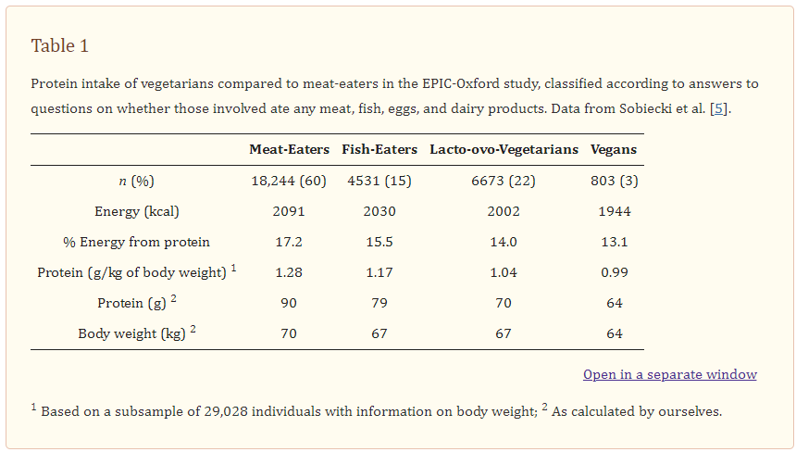

### **2.1.2 The risk of protein consumption**

At the same time, it is crucial to understand that an excessive amount of protein can cause damage for some populations, consumption of mostly animal protein can be risky; therefore, even for meat lovers, it is critical to combine protein that originates from plants, as well as cheese and milk. Hannon and colleagues (2000) revealed that consuming animal protein in an older population at levels many times higher than the RDA resulted in increased bone density and a significant decrease in fracture risk. [18]

## **2.2 Personal Nutrition**

Several studies have found that eating a high-quality diet or following a smart dietary pattern is inversely associated with a lower risk of mortality. As a result, governments are attempting to promote healthy lives by creating food and health guidelines and recommendations. One of the most significant challenges discovered is that individual reactions to dietary guidance and intervention are varied, highlighting the need for precision or personalized nutrition (PN) for each individual. There are various "levels" of customization, ranging from basic surveys to tailored supplements.

PN involves several aspects, including food consumption, physical activity, individual features unique to each person, dietary advice, dietary products and supplements, and more. All of this knowledge contributes to understanding and developing unique nutritional advice for each individual. PN has enormous potential for disease prevention, particularly when paired with the power and accessibility of mobile technologies.[1]

## **2.3 Technology- pros and cons**

Advances in technology have resulted in an increased use of electronic devices such as tablets and mobile phones. It is estimated that over 5,000 million people worldwide own mobile devices, with smartphones accounting for more than half of them.

Children and teenagers are increasingly the primary users of these devices, in addition to adults. For example, digital technologies play a vital role in young people's daily life, as they are utilized to search for relevant information such as health, medicines, and drugs. One of the primary benefits of these devices are mobile applications (APPs), which may be used for a variety of purposes (games, shopping, public services, and so on). Mobile health applications (mHealth) are becoming increasingly popular for health promotion and chronic disease prevention. mHealth has enormous promise, particularly in terms of cost-effectiveness and creativity. Currently, there are an estimated 300,000 mobile health applications accessible, with approximately 10,000 focused on nutrition and food. In some regions, diet-related apps were rated second in the Google Play Store's 'health and fitness' category in 2020. However, due to the enormous number of nutritional APPs and their potential commercial value, it is critical to distinguish between those with a scientific basis and those without. Not all APPs provided to customers are always trustworthy, useful, and of high quality, nor are health professionals or researchers involved in their development. Most of the time, a wrong approach can harm the user's health and lead to unhealthy eating habits. [16]

## **2.4 Chat GPT**

State-of-the-art linguistic model ChatGPT has significantly transformed the field of natural language processing. Text that closely resembles human language can be achieved by taking into account the context and ensuring consistency. This advancement facilitates increased interaction between humans and AI. Its exceptional performance in several language activities and benchmarks has positioned it as a prominent language model globally. ChatGPT's sophisticated language modeling has the potential to enhance human-computer and human-machine communication, making it more authentic and intuitive. ChatGPT has undergone extensive pre-training using a large amount of text data to grasp the nuances of language and generate accurate responses, even in challenging and unclear situations. ChatGPT's capacity to acquire knowledge from structured and unstructured input renders it a versatile conversational AI tool. The system's advanced neural architecture enables it to efficiently handle various inputs and generate highly tailored responses, resulting in a more captivating and gratifying user experience.

### **2.4.1 AI in nutrition apps**

Artificial intelligence (AI) has increased its applications in medicine and biomedical sciences, with an emphasis on medical diagnosis, disease risk prediction, treatment approach assistance, and other areas. Several nutrition applications have been created concurrently, including microbiota/genes-diet interactions, diet-disease link research, chatbots for lifestyle intervention, dietary evaluation using food pictures, and food composition applications.[1]

In general, AI should cause no harm and contribute to human well-being, and AI experts should be honest, trustworthy, and fair. Privacy and confidentiality must be respected. Other problems include the "dehumanization" of care, social disparities, assigning accountability in the event of failures or malfunctions, and biases in training models and care delivery. There is also serious concern that AI systems in nutrition and dietetics would partially replace dietitians; nevertheless, health professionals can incorporate such technology into their job. The usage of AI applications for people with mental illnesses or eating disorders is also critical.[1]

To summarize, AI-assisted customized nutrition requires further justification, while the regulatory framework must be constantly updated to keep up with scientific advances and address ethical concerns. A coordinated worldwide focus on these domains could lead to more widespread acceptance of AI in people and populations. [1]

AI can assist create personalized nutrition diet recommendations. Bioinformatics and artificial intelligence can help uncover biomarkers linked to specific nutritional therapies or diseases [2]. The information presented above can be used to better understand the molecular mechanisms underlying nutrition-related disorders and to lead the creation of more specific therapies. By combining bioinformatics' computational power with AI's advanced algorithms and learning capabilities, researchers can gain a better understanding of nutrition-related effects, develop personalized interventions, and make evidence-based recommendations to improve individual health and well-being. The Nutri-Educ algorithm, developed to induce dietary modifications, is one example of a personalized nutrition database [3].

### **2.4.2 Ethical and other concerns regarding the use of AI in nutrition**

Stephen Hawking emphasized the significance of ethics in science and technology by stating, "Our future depends on how wisely we use the growing power of technology." The Association for the Advancement of Artificial Intelligence has outlined various ethical aspects of AI, which are presented in Table 1. Some of these points, along with additional ones, are currently being further studied in nutrition research and practice.[1]

Table 1. General ethical aspects regarding AI.

| * •AI should contribute to society and to human well-being. * •AI should do no harm. * •AI professionals should be honest and trustful. * •Persons engaged in AI should be fair and not discriminate. * •Persons engaged in AI should respect the work required to produce new ideas, inventions, creative works, and computing artifacts. * •Privacy and confidentiality should be protected. |
| --- |

## **2.5 Dietary assessment with the use of food images recognition techniques**

There are various difficulties in dietary assessment, both at the research and individual levels [4]. Several analysis techniques have been developed, including principal component analysis to identify dietary [5,6] and meal patterns [6], although they are still based on self-reported data. Food picture identification is considered a unique technology, aided by deep learning methodologies [7], with rising capacity as food databases grow [8]. For example, the "NutriNet" tool was presented and rigorously tested on over 225,000 photos of 520 foods and beverages [9], while the GoCARB application proved as effective in carbohydrate estimation as dietitians [10]. The goFOOD™ app estimates calorie and macronutrient content of meals using smartphone photographs [11]. These new technologies could therefore potentially improve dietary assessment in human studies [7].

### **2.5.1 Food Detection and Recognition Using Convolutional Neural Network**

Ensuring sufficient nourishment from regular meals is crucial for our well-being. In order to be aware of the contents of our meals, it is common practice to keep a log of our daily food intake. Typically, meal recording involves manually describing the food using language. However, this manual process is laborious and time-consuming. In order to address this challenge, efforts have been made to facilitate meal tracking through the utilization of information technology. Utilizing image recognition technology for food items could be an effective method for recording food. Photographing the scene would serve as an adequate means of documentation. Nevertheless, it is evident that there exists a vast array of dietary varieties. Even among foods that belong to the same category, there is a significant amount of variation. Consequently, despite efforts to recognize food items, the performance of recognition is still unsatisfactory.

Image recognition has lately employed deep learning techniques. Deep learning refers to a group of algorithms that utilize a complicated architecture to tackle intricate issues. One notable attribute is that during training, superior visual attributes for recognition are extracted automatically. The convolutional neural network (CNN) is a method that fulfills the criteria of the deep learning approach. CNN has emerged as a cutting-edge technique for tackling image identification challenges, including the prestigious Large Scale Visual identification Challenge.

We have discovered a research study that demonstrates the utilization of Convolutional Neural Networks (CNN) for the purpose of identifying and detecting food photographs. The paper also assesses the effectiveness of this approach. The contributions can be summarized as: (1) A dataset was created for food recognition experiments using images from a publicly accessible food logging system. (2) The hyperparameters of a CNN were optimized, showing that the CNN greatly improved the accuracy of food recognition compared to a traditional method that used a support vector machine (SVM) with manually designed features. (3) By examining the trained CNN, it was discovered that color features play a dominant role in the food recognition process. (4) It was demonstrated that CNN outperforms a baseline method significantly in the task of food detection.[19]

# 

#### 

#### 

#### 2.5.1.1 Food recognition

CNN has hyper parameters related to the number of layers, training, preprocessing, and initialization. The module we are using scales the dataset images to 80x80, using python for training and testing which randomly crops the images for 64x64. The dataset is then divided into six sets: four sets used for training, one for validation, and one for testing[19].

#### 2.5.1.2 Food detection

Food detection is a binary classification of food and non-food images. By giving an image that contains food and background, food detection classifies the image as food or non-food. For food detection the module used 1234 general food images and 1980 non-food images, including human faces and landscapes. The images were scaled to 80x80 and cropped to 64x64 randomly. The module uses 8 groups of images for training, one for validation, and one for testing. For this method, SVM was used as the classifier and employs color features, circular boundary features, and SIFT-BoW features as image features[19].

# **3. Expected Results/Achievements**

Creation of an artificial intelligence application with a focus on nutrition is our primary goal. Not only will it produce helpful findings, but it will also go beyond tracking calories. The program will take into account the individual requirements and health circumstances of its users, such as their workout routines, dietary restrictions (such as sugar intolerance or medical disorders), and allergies.

In addition, the application will be designed to meet the requirements of the users, and it will have a user interface that is easy to understand, which will make it more user-friendly. The model will be able to generate recipes based on historical data while taking into consideration user-specific conditions. This will be accomplished by utilizing advanced technologies such as artificial intelligence.

In addition, while a sizable portion of the currently available nutrition applications primarily focus on dietary modifications that are helpful to weight loss, our program takes a different approach by giving priority to a wider range of objectives, including the acquisition of muscle and other fitness-related goals, in addition to allergic conditions and medical conditions.

Moreover, one of our primary goals is to make it easy for customers to upload photographs of the food they have consumed. The image will be evaluated by our technology in an effective manner, and advice will be provided regarding what information should be included in order to accomplish their nutritional goals. Customers are guaranteed to have a clear understanding of the process and the ability to easily implement it in order to alter their eating habits because this feature has been specifically designed to run without any interruptions.

# **4. Challenges**

* Ensuring that the data used is accurate and reliable. This is a crucial step for providing precise nutritional recommendations.
* Adapting the application to meet the needs of the user, including the dietary restrictions, allergies, and medical conditions.
* Creating an intuitive and user-friendly interface that facilitates seamless interaction with the app, balancing simplicity with functionality.
* Integrating AI applications with existing platforms, devices, and technologies may pose some challenges.
* Validating the accuracy and efficacy of the AI model through rigorous testing and validation procedures is essential.
* Integrating APIs with the application, especially with complex models like GPT-4, and ensuring smooth synchronization with the database can be problematic.
* Verifying the information received from GPT-4 against a trusted database is crucial.
* Identifying and marking recipes that are not suitable for specific dietary needs.
* Maintaining data consistency between the application and the database when multiple users are interacting with the system simultaneously.
* Conquering the challenge of recognizing food from a poor-quality, highly magnified image that lacks discernible details.
* Ensuring seamless functionality of the image recognition tool to offer customers convenient options for submitting meal images and receiving precise nutritional recommendations.
* Make sure the accuracy of the nutritional analysis conducted by the picture recognition system in order to efficiently fulfill users' dietary objectives.
* Translating units and recipe instructions produced by AI from intricate or complicated formats into straightforward, precise English that people may readily comprehend and adhere to. This involves converting measurements, culinary terminology, and ingredient labels into a format that is easier for users to understand.

Unique features:

* Utilizing AI, the app could generate personalized recipes based on user preferences, nutritional requirements, and available ingredients. It could also consider factors like cooking skills, time constraints, and dietary restrictions.
* The app could feature an interactive meal planning tool that allows users to customize their meal plans based on their goals.
* The application has the capability to acquire knowledge from the user on their preferences and food choices in order to consistently improve based on user feedback and behavior.

# **5. Research /Engineering Process**

To this point, the information gathering and learning process has primarily focused on two main aspects of the project: theoretical knowledge, which involves understanding nutrition and its impact on human health, and practical considerations regarding the integration of AI.

## **5.1 Research - Nutrition & Nutrition applications**

In our pursuit of expanding our comprehension of nutrition, we directed our attention towards addressing the following questions:

* ⁠How do dietary choices impact individuals' health, and what are the indicators for determining whether to adopt a new nutritional regimen or not.
* Which age group needs the greatest attention?
* What non-technological options are accessible for nutrition applications?
* What are the limitations of the present applications and how can ours improve upon them?

In order to address these inquiries and enhance our understanding, we utilized a diverse array of resources, including scientific publications, articles, and videos. After reviewing the available materials, we convened to discuss our findings and exchange the key aspects that require our attention during the application development process. While studying nutrition in relation to developing an application, we found that the wide range of dietary alternatives necessitates the inclusion of a questionnaire prior to conducting an evaluation in the simulation.

Discovering a correlation between the questionnaire and our final analysis would confirm the effectiveness of our nutrition application.

Furthermore, we determined that the primary demographic to focus on should be individuals in the middle-aged category, specifically adults between the ages of 25 and 40.

## **5.2 Research - AI and ChatGPT:**

In our exploration of the intersection between artificial intelligence (AI) and nutrition, we directed our focus towards addressing the following questions:

* How can AI technologies enhance personalized nutrition recommendations and dietary choices for individuals?
* What role can ChatGPT or similar conversational AI models play in providing interactive and engaging interfaces for discussing nutritional needs and meal planning?
* In what ways can ChatGPT generate customized meal plans based on individual nutritional needs, including calorie requirements, dietary restrictions, and taste preferences?
* What role can ChatGPT play in providing real-time nutritional guidance and answering questions about specific foods, ingredients, and portion sizes?
* What capabilities does ChatGPT have in suggesting ingredient substitutions or modifications to align with personalized nutrition goals (e.g., reducing sugar, increasing fiber)?
* How can ChatGPT integrate with health tracking devices (e.g., fitness trackers, smart scales) to incorporate real-time health data into personalized meal planning recommendations?

By exploring these questions, we aim to harness the potential of ChatGPT as an innovative tool for personalized meal planning and nutritional support, empowering individuals to make informed choices and achieve their dietary goals effectively.

During our investigation on the convergence of artificial intelligence (AI) and nutrition, we specifically aimed to tackle the following inquiries:

In what ways may AI technology improve personalized nutrition recommendations and dietary choices for individuals?

AI technologies have the potential to greatly improve personalized nutrition recommendations by evaluating extensive data, such as individual health profiles, dietary preferences, and previous eating behaviors. Artificial intelligence systems have the capability to analyze this data in order to detect precise nutritional requirements and customize recommendations accordingly. This results in more precise and pertinent nutritional guidance that is tailored to each person, aiding them in accomplishing their health and nutrition objectives more efficiently.

What function may ChatGPT or comparable conversational AI models serve in offering interactive and captivating interfaces for discussing dietary requirements and meal preparation?

ChatGPT and comparable conversational AI models can function as interactive and captivating interfaces for users to converse about their dietary requirements and meal preparation. These models possess the ability to comprehend queries expressed in natural language and deliver responses that are simultaneously instructive and conducive to discussion. This connection enhances user comfort and engagement, thereby motivating people to actively seek guidance and make well-informed choices regarding their dietary habits. ChatGPT's conversational character can facilitate the comprehension of intricate nutritional information, rendering it more accessible and user-friendly.

How can ChatGPT create personalized meal plans that consider specific nutritional demands, such as calorie requirements, dietary restrictions, and taste preferences?

ChatGPT may create personalized meal plans by utilizing its capacity to analyze and comprehend specific user input regarding their nutritional requirements, including calorie demands, dietary limitations (such as gluten-free or vegan), and taste preferences. By integrating this data, ChatGPT may provide personalized meal plans that are customized to the individual characteristics of each user. These plans might consist of a range of meal choices that correspond to the user's nutritional objectives and tastes, guaranteeing a well-rounded and pleasurable diet.

How can ChatGPT contribute to offering immediate nutritional advice and addressing inquiries regarding particular meals, components, and serving sizes?

ChatGPT has the capability to offer immediate nutritional advice by answering user questions regarding particular foods, ingredients, and serving sizes. Users can inquire with ChatGPT about the nutritional composition of different foods, suitable serving sizes, and the compatibility of various substances with their dietary regimen. The prompt availability of nutritional information enables consumers to make well-informed choices while on the move, be it during grocery shopping, cooking at home, or dining out.

What functionalities does ChatGPT possess in recommending ingredient replacements or adjustments to fit with individualized nutrition objectives (e.g., decreasing sugar, enhancing fiber content)?

ChatGPT can propose ingredient substitutions or adjustments to match individualized nutrition objectives. For instance, if a user desires to decrease their consumption of sugar, ChatGPT can suggest substitute sweeteners or foods that have a lower sugar content. Similarly, ChatGPT can provide recommendations to users who want to enhance their fiber consumption by suggesting the inclusion of high-fiber foods in their meals. These suggestions assist users in modifying their preferred dishes to align with their dietary objectives while maintaining flavor and diversity.

How can ChatGPT be integrated with health tracking devices, such as fitness trackers and smart scales, to include real-time health data in personalized meal planning recommendations?

ChatGPT has the capability to connect with health tracking devices and retrieve up-to-date health data, including metrics like activity levels, weight, and other biometric information. By integrating this data into its research, ChatGPT can offer more precise and adaptable meal planning suggestions. For example, when a user's fitness tracker shows a significant amount of physical activity, ChatGPT can modify the meal plan to guarantee sufficient calorie and nutrient consumption to sustain their level of activity. This integration guarantees that the nutritional guidance is not only tailored but also adaptable to the user's present health condition and lifestyle. One viable approach we discovered is the utilization of the Apple HealthKit API. Apple offers HealthKit, a framework that enables applications to retrieve health and fitness data from the Apple Watch and other devices. Developers have the ability to seek authorization to access and modify data stored in the user's Health app.

Upon closer examination, we acknowledged the intricacy and possible privacy issues linked to the integration of ChatGPT with health monitoring devices. The practical obstacles of acquiring user consent, guaranteeing data security, and adhering to privacy standards posed substantial issues. Additionally, the large quantity and diverse nature of health data produced by these devices presented difficulties in terms of data processing and analysis.

After carefully considering these factors, we eventually chose not to pursue this integration method. Instead, we chose to concentrate on improving the fundamental features of ChatGPT and augmenting its capacity to offer customized nutritional guidance based on user input and preferences. Although the incorporation of health tracking devices is an interesting possibility for future advancement, we determined that placing importance on simplicity, usefulness, and data privacy was crucial in guaranteeing a favorable user experience.

In conclusion

Through the examination of these inquiries, we have discovered numerous methods in which ChatGPT can utilize the capabilities of artificial intelligence to improve individualized meal planning and nutritional assistance. ChatGPT offers personalized meal plans, live nutritional advice, and interactive platforms for addressing dietary requirements. In addition, it has the capability to propose alternative ingredients and seamlessly connect with health monitoring devices to provide dynamic and tailored suggestions. These features enable individuals to make well-informed decisions and successfully attain their nutritional objectives, showcasing the revolutionary potential of ChatGPT as a tool for customized nutrition.

## **5.3 Our process approach:**

* Problem definition: The initial phase involves comprehending the constraints associated with current nutrition applications, encompassing the identification of project-specific goals and objectives, particularly focused on enhancing outcomes.
* Literature review: During this phase, we will conduct an extensive examination of pertinent literature in nutrition, nutrition applications, and AI to uncover methodologies and approaches. This process aims to deepen our understanding of nutrition methodologies and pinpoint areas within the literature that our project can address.
* Data collection: During this phase, we will gather and organize an extensive dataset comprising nutrition and food-related information. This dataset will encompass nutritional values, food, dishes and other relevant data.
* Algorithms selection: During this phase, we will carefully choose the most suitable algorithms and AI techniques for the task, and optimize the model’s architecture to align perfectly with the data and the problem at hand.
* AI integration: Following model refinement, we will leverage AI tools for various purposes, this integration will enhance the capabilities of our application, enabling sophisticated functionalities such as personalized nutrition plan, and other relevant tasks.

# **6. Product**

This section contains crucial diagrams, such as the Use Case diagram, Activity diagram, and Class diagrams. These graphic representations provide a thorough understanding of how our system works, including its workflow and structure. They demonstrate how it effectively incorporates different dietary preferences to empower users in their pursuit of a healthy lifestyle.

## 

## **6.1 Use Case Diagram**

A use case diagram visually represents the potential interactions between a system and its users, illustrating the diverse scenarios in which users engage with the system. It presents a spectrum of use cases and user roles, offering a holistic view of the system’s functionalities.

### 

## **6.2 Activity Diagram**

Activity diagrams serve as depictions of procedural sequences and actions, capturing the flow of activities with provisions of decision-making, repetition, and simultaneous execution. These diagrams aim to portray not only computational algorithms but also organizational workflows, along with the intersections of data streams associated with the respective activities.

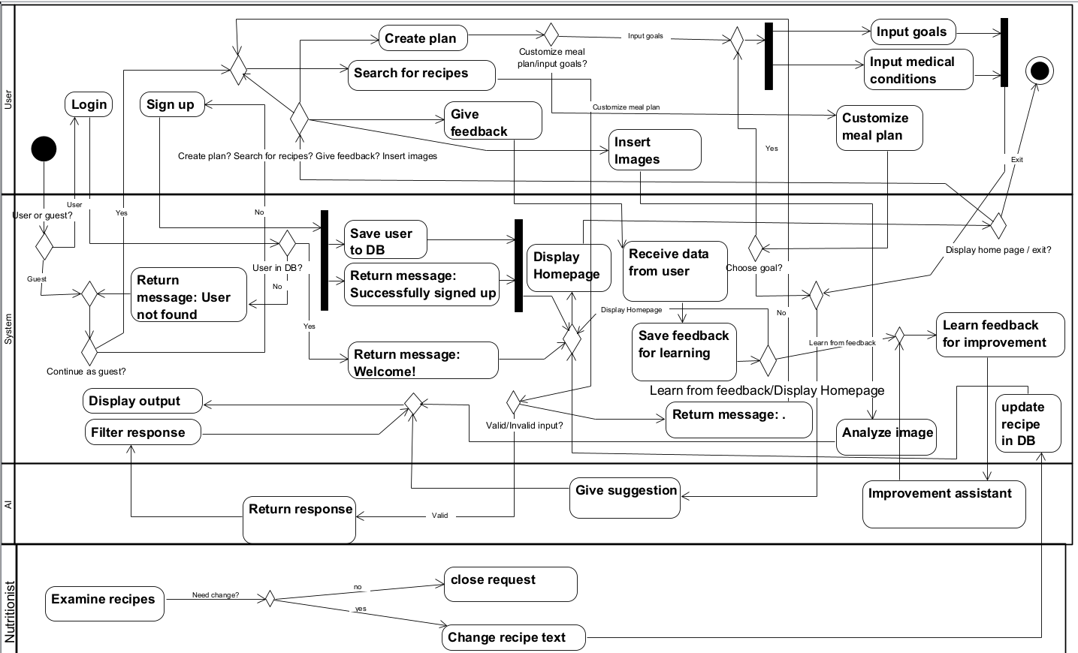

## **6.3 Class Diagram**

The class diagram illustrates the architecture of the objects within the proposed system, showcasing the relationships between these objects and the functions they can execute. Additionally, it depicts the connections between the users and the screens pertinent to each. 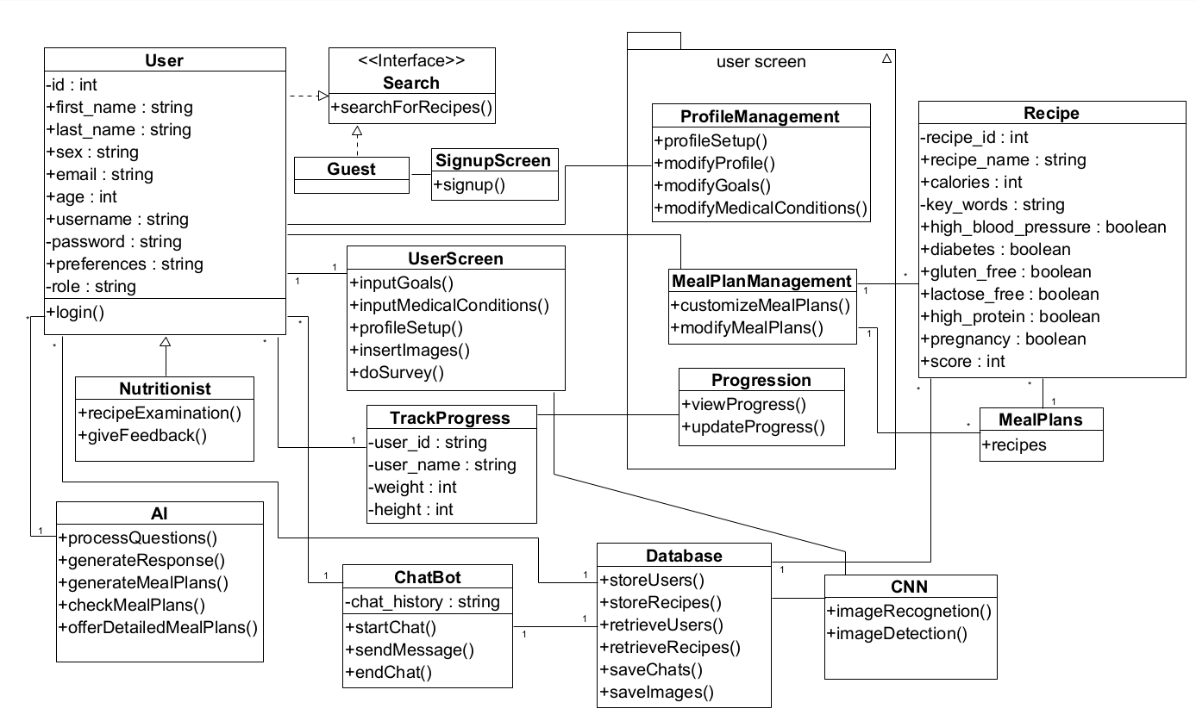

# **7. Algorithm**

The algorithm for interpreting the user's input operates in the following manner: the system receives the submitted text and sends a query, utilizing an API, to chat-GPT. This query includes a pre-prepared explanation, which will be appended to the user's content.

Initially, it is necessary to determine the subject of the message in order to determine whether a dietician request should be initiated, whether a recipe should be provided in the chat box for the user to peruse, or whether the user is seeking assistance with a programming course assignment and asking completely irrelevant questions.

In order to determine the answer to that, we can prompt chat-GPT to categorize the text based on specific keywords that we provide. For instance, if the text contains a complaint about a recipe, the system would identify the keyword "feedback" and initiate the procedure of submitting an application to a nutritionist.

In this scenario, it is necessary to save the text that is returned into the system. We require it for the purpose of uploading this information to a nutritionist user, thereby storing the content in the selected database - MongoDB.

We choose MongoDB due to its excellent user experience, ability to handle complex queries using robust query languages, secure database features, and compatibility with cloud-based operations.

Furthermore, if the chatbot GPT generates the term "error" due to the text not being relevant to the provided parameters, the system will display an error message advising the user to only submit relevant inquiries.

One novelty in our system is the feature that allows users to upload an image and request specific nutritional information from the system. The user will input their desired quantity of protein into the system, which will then evaluate the uploaded image and recommend additional items to meet the specified protein requirement. In order to minimize chat-GPT interaction and facilitate text analysis, we have implemented predefined text fields for users to input their desired meal values. Users have the option to enter or omit data in these boxes. Here are a few examples: "maximum caloric intake, protein quantity, carbohydrate quantity," and so on.

In order to incorporate image analysis into the project, we opted to utilize tensorflow for the purpose of picture recognition. The algorithm operates in the following manner: the user submits images of the food they are consuming, and the system employs a Convolutional Neural Network (CNN) that is already integrated into the tensorflow framework to discern the contents of the image. The TensorFlow algorithm outputs a list of five words together with their corresponding probabilities of being associated with the image.

One difficulty that emerged at this time is the issue of amounts. Can the system accurately determine the precise caloric content of the food just based on a picture? Can one distinguish between a hamburger containing a patty weighing 160 grams and a hamburger including a patty weighing 500 kilos? The quantity of salad seen in the picture is directly influenced by the angle at which the shot was taken.

In order to address this issue, we choose to request the user's input, including submitting a photo, and have them grade the portion size as either average, below average, or above average. We will append the user's response to the inquiry submitted to the chatbot GPT and inquire about the "caloric value of a hamburger that exceeds the average size".

The reason for selecting tensorflow was its extensive ecosystem, scalability, and strong community support. It provides advanced application programming interfaces (APIs) such as Keras for effortless construction of models and seamlessly connects with platforms such as Google Cloud Platform. Furthermore, TensorFlow incorporates enhancements in performance and offers assistance for distributed training, rendering it appropriate for both research and production settings.

In our dynamic nutrition application, we’ve built a sophisticated algorithm that integrates cutting-edge artificial intelligence (AI) capabilities to engage users in personalized conversations about their dietary preferences and goals. Through natural language processing and machine learning, our AI assistant, ChatGPT, adeptly understands user queries and adapts its responses over time, continuously learning from each interaction.

To ensure that our recommendations are tailored to the specific needs of each user, our system generates customized API requests that meticulously frame the conversation and extract relevant recipe suggestions from ChatGPT.

These requests are crafted to consider a myriad of factors, including dietary preferences, allergies, cultural considerations, and health objectives.

Moreover, our application is seamlessly integrated with a comprehensive database that houses verified nutritional information, enabling us to cross-reference recipe recommendations and ensure accuracy and suitability.

Specialized checks are incorporated into the algorithm to address specific dietary requirements, such as suitability for pregnant women or individuals with medical conditions like diabetes or gluten intolerance.

Recipes that align with these criteria are prioritized for presentation to the user, while those that pose risks or contravene dietary guidelines are flagged accordingly.

Furthermore, our application goes beyond text-based interactions by offering users the ability to upload images of their meals for analysis. Leveraging image recognition technology, the application accurately identifies ingredients and calculates the precise caloric content and nutritional profile of each dish.

This detailed analysis empowers users to make informed decisions about their food choices and dietary intake.

Beyond offering curated suggestions, our application empowers users to take control of their nutritional journey by facilitating the creation of custom meal plans. Users can craft their ideal menus, which are then sent to ChatGPT for further refinement and feedback, leveraging the AI’s expertise to optimize nutritional balance and culinary enjoyment. Additionally, we’ve integrated a valuable resource into our platform: nutritionists who provide expert guidance and feedback directly through the application.

This synergy between AI driven insights and human expertise ensures that users receive comprehensive, well-rounded support on their quest for optimal health and wellness.

Through this holistic approach, our application not only delivers unparalleled accuracy and personalization but also fosters a collaborative environment where users can confidently navigate their dietary choices with the guidance of cutting-edge technology and seasoned nutritional experts.

Additionally, the application allows a robust feedback mechanism that encourages user engagement and enables us to continuously refine and improve our algorithm based on user input.

By fostering a collaborative relationship with our users, we ensure that our application evolves in tandem with their evolving needs and preferences, delivering unparalleled accuracy, personalization, and user satisfaction.

In essence, our algorithmic approach combines cutting-edge AI technology with a robust database infrastructure to deliver personalized nutrition guidance that is both precise and adaptable to the ever changing needs of our users.

# **8. Application Screens**

click on ‘continue as a guest’

click on ‘login’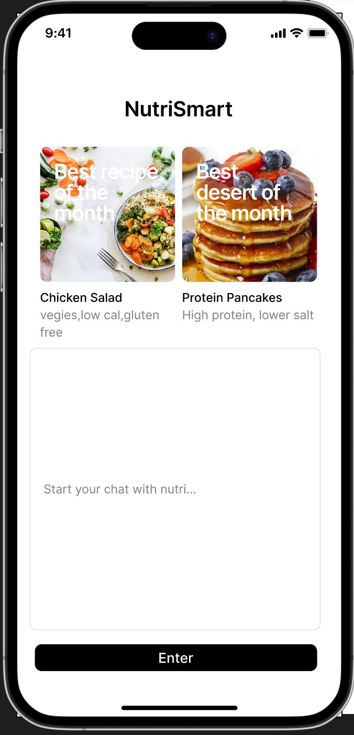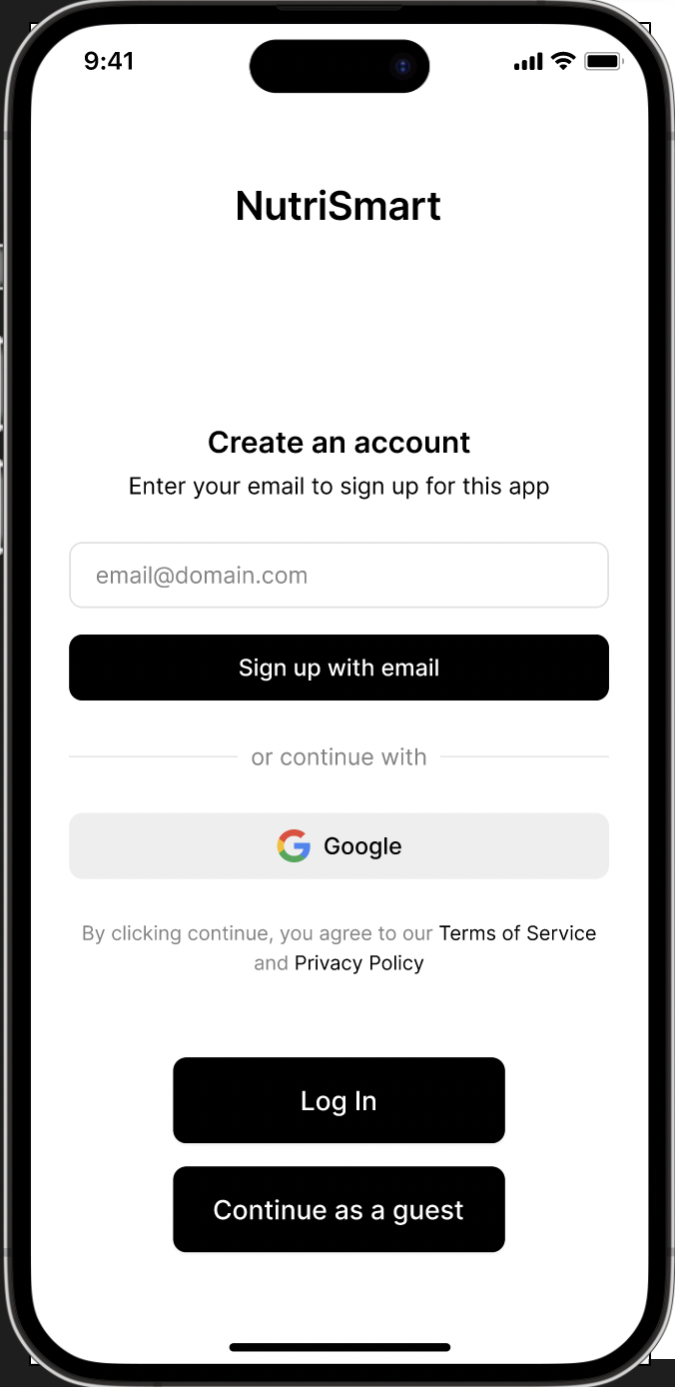

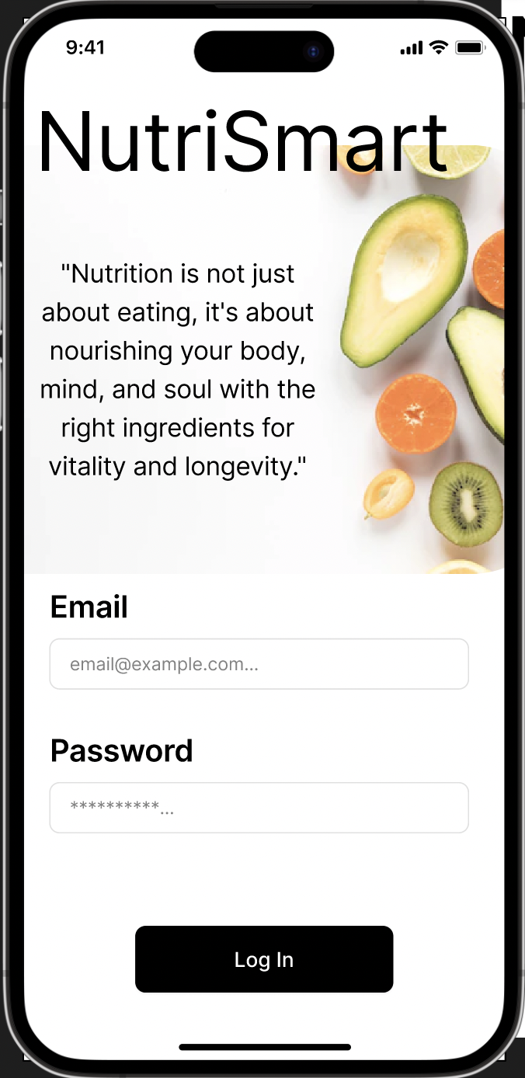

user screen

# 

Nutritionist screen

# 

upload a picture

-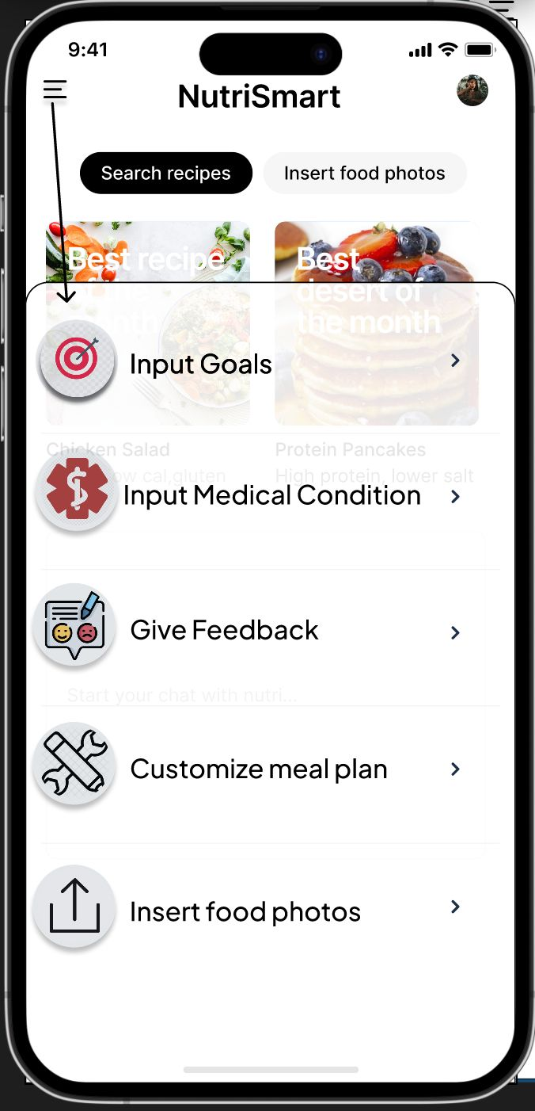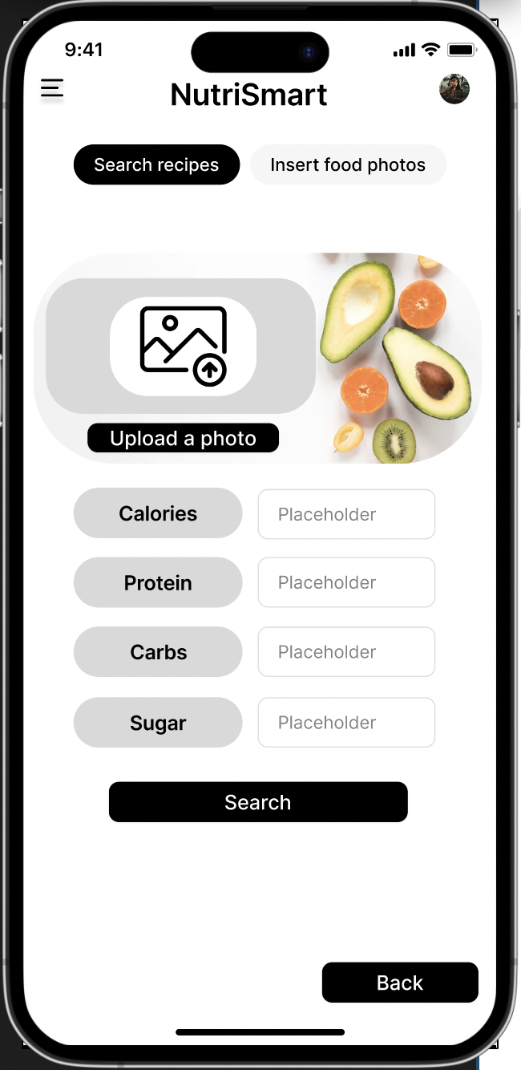

# **9. Testing Plan**

* Accuracy: the application should provide accurate recommendations for users’ nutritional needs and goals. Success can be measured by comparing the app’s results and recommendations with established nutritional guidelines and standards.
* Allergy Detection Accuracy: Ensure the app precisely detects and takes into consideration all allergies specified by the user. Failure to accurately detect or overlook allergies may result in significant health complications for the individual.
* Customization and Personalization: The application should offer tailored meal plans that take into account the user’s specific allergies, dietary preferences (such as vegetarian, vegan, or keto), nutritional needs, and potentially even cultural or religious dietary limitations.
* Diversify and Innovative food plans: Provide an extensive range of food choices to accommodate diverse palates and preferences. Introducing innovative and delectable meal recommendations can improve user contentment and commitment to the application.
* Nutritional Balance: Ensure that the suggested meal plans are nutritionally balanced and fulfill the user’s dietary requirements, including enough consumption of vital nutrients, vitamins, and minerals.
* intuitive and User-friendly interface: The application should include an interface that is easy to understand and browse, allowing users to effortlessly input their preferences and explore the available meal selections. Concise directions and visually intuitive graphics can improve the user-friendliness of a product or system.
* Ingredient Substitution and Flexibility: Offer alternatives for ingredient substitutions to satisfy individual tastes and the availability of ingredients. Users should have the capability to modify portion sizes and servings to accommodate their own requirements.
* Platform Integration: Contemplate combining the application with well-known platforms such as fitness trackers or supermarket delivery services to offer a smooth user experience and improve convenience.
* Feedback and Improvement Mechanism: Implement a feedback system that allows users to offer input on meal recommendations, indicate any allergies or preferences, and propose enhancements. Regular updates and additions, informed by a user feedback, can ensure the app remains pertinent and valuable.
* Data Security and Privacy: Guarantee the safeguarding and preservation of user data, encompassing allergy information and dietary preferences. Comply with pertinent data protection regulations in order to establish confidence with users.
* The app’s effectiveness: The app’s effectiveness can be determined by evaluating its influence on users’ health outcomes. Track key indicators such as increased compliance with dietary guidelines, enhanced allergy control, and overall enhancement in nutritional consumption.

login or chat as a guest:

| Successful user login | Email : “tester@gmail.com”  Password:"12345"  Press: "Login". | The System opens the main window of a user. |
| --- | --- | --- |
| Failed Login - wrong password | Email : “tester@gmail.com”  Password:"45454"-(Wrong Password)  Press: "Login". | The system informs the user that this password is wrong and lets him try again. |
| Successful nutritionist login | Email : “nutri@gmail.com”  Password:"123123"  Press: "Login" | The System opens the main window of the nutritionist user. |
| Failed Login - user doesn’t exist | Email : “tester@gmail.com”  Password:"45454"-(Wrong Password)  Press: "Login". | The system informs the user that this user doesn’t exist and lets him try again. |
| Successful chat as a guest | The guest is typing his requirements and press Enter | The system analyzed his text and response with a recipe that suit his request |
| Failed chat as a guest | The guest inserts a text that does not nutrition related and press Enter | The system apologizes and responds with a notice indicating that the request is unrelated to nutrition. |

chat as a user:

| Successful chat request | The user submits a request for a recipe.  Press the enter key. | The system generates the recipe based on the user's request and displays it in the chat box. |
| --- | --- | --- |
| Successful preferences update | The user provides their feedback on the provided recipe and clicks the Enter key. | The algorithm processed the text and revised the recipe score. |
| Successful feedback | The user will identify the shortcomings of the recipe and inform the chatbot by composing a comment and pressing the "enter" key | The system will assess the content as a review and generate a warning regarding the nutritional aspects. |
| Failed chat request | The user submits a request for a recipe.  Press the enter key. | The algorithm is unable to analyze his content as a genuine request due to the presence of spelling errors and inadequate syntax. |

update alerts

| Successful update for wrong recipe | The nutritionist will dismiss the popup notice once they have resolved the recipe errors. | The system will designate the alert as completed and transfer it to the archive. |
| --- | --- | --- |
| Successful recipe analyze | The nutritionist will verify the validity of the reasons for the failure and, if confirmed, use the option 'change recipe' to modify the tags associated with the recipe. | The system will display the tags associated with this recipe on the nutritionist screen. |
| Successful recipe update | The nutritionist will analyze the recipe content and modify it based on the complaint before clicking 'enter'. | The system will modify the content and the settings of the recipe. |
| Failed recipe update | The nutritionist type in empty string | The system will present a popup window that say “no empty field is allowed” |

Image recognition

| Successful food image with one request. | The user uploads a standard image of food-a plate with rice.  requesting 20g protein | The system accurately identifies and responds to the user to add 150g of chicken breast to the dish. |
| --- | --- | --- |
| Successful food image with more than one request. | The user uploads a standard image of food-a plate with rice.  requesting 20g protein and maximum 600 calories. | The system accurately identifies and responds to the user to add 150g of chicken breast to the dish. |
| Failed zoomed-in food image with one request. | The user inserts a zoomed in sandwich with bacon and cheese.  requesting for 450 maximum calories. | The system identifies only the bread, and suggests the user to add one spoon of Mayo and five slices of Salami. |
| Failed zoomed-in food image with more than one request. | The user inserts a zoomed in sandwich with bacon and cheese.  requesting for 450 maximum calories, 200g of carbs and 25g of protein. | The system identifies only the bread, and suggests the user to add one spoon of Mayo and five slices of Salami. |
| Failed blurred food image. | The user inserts a picture that is highly blurred, requesting to calculate how many calories in the dish. | The system couldn’t identify the food in the dish due to high blurr level, and suggests the user to insert a clear image. |
| Successful image with multiple food items in it, with more than one request. | The user inserts a picture with meatballs, rice, broccoli, requesting for 100g carbs, 34g proteins. | The system accurately identifies and responds to the user to reduce two spoons of rice, and two meatballs. |

# 

# **10. References**

[1] <https://www.sciencedirect.com/science/article/pii/S2667268523000311>

[2] <https://ieeexplore.ieee.org/document/9643408> D. Panagoulias, D. Sotiropoulos, G. TsihrintzisBiomarker-based deep learning for personalized nutrition

[3]<https://www.sciencedirect.com/science/article/abs/pii/S0933365707001637?via%3Dihub> J.-C. Buisson

Nutri-Educ, a nutrition software application for balancing meals, using fuzzy arithmetic and heuristic search algorithms

[4] [Google Scholar](https://scholar.google.com/scholar_lookup?title=Nutritional%20epidemiology&publication_year=2012&author=W.%20Willett) W. Willett Nutritional epidemiology

(3rd ed.), Oxford University Press, New York (2012)

[5] <https://www.plefa.com/article/S0952-3278(20)30192-7/abstract> E. Fragopoulou, P. Detopoulou, E.Alepoudea, T. Nomikos, N.Kalogeropoulos, S. Antonopoulou

Associations between red blood cells fatty acids, desaturases indices and metabolism of platelet activating factor in healthy volunteers

[6] <https://www.mdpi.com/2079-9721/10/3/64> P. Detopoulou, V. Dedes, D. Syka, K.Tzirogiannis, G.I. Panoutsopoulos

Mediterranean Diet, a Posteriori Dietary Patterns, Time-Related Meal Patterns and Adiposity: Results from a Cross-Sectional Study in University Students

[7]<https://www.cambridge.org/core/journals/british-journal-of-nutrition/article/diets-nutrients-genes-and-the-microbiome-recent-advances-in-personalised-nutrition/8D623DF612071485B4AD712F4D59EA33> N.V. Matusheski, A. Caffrey, L.Christensen, S. Mezgec, S. Surendran, M.F. Hjorth, *et al.*

Diets, nutrients, genes and the microbiome: recent advances in personalised nutrition

[8]<https://ieeexplore.ieee.org/document/8678916> Q. Cai, J. Li, H. Li, Y. Weng

BTBUFood-60: dataset for object detection in food field. 2019 IEEE international conference on big data and smart computing (BigComp)

[9] <https://www.mdpi.com/2072-6643/9/7/657> S. Mezgec, B. Koroušić Seljak

NutriNet: A Deep Learning Food and Drink Image Recognition System for Dietary Assessment

[10] <https://www.mdpi.com/2072-6643/10/6/741> M.F. Vasiloglou, S. Mougiakakou, E.Aubry, A. Bokelmann, R. Fricker, F.Gomes, *et al.*

A Comparative Study on Carbohydrate Estimation: GoCARB vs. Dietitians

[11] <https://www.mdpi.com/1424-8220/20/15/4283> Y. Lu, T. Stathopoulou, M.F.Vasiloglou, L.F. Pinault, C. Kiley, E.K.Spanakis, *et al.*

goFOODTM: An Artificial Intelligence System for Dietary Assessment

[12] Glinoer, D. (2007). The importance of iodine nutrition during pregnancy. *Public health nutrition*, *10*(12A), 1542-1546.

[13] Maughan, R. J., & Shirreffs, S. M. (2012). Nutrition for sports performance: issues and opportunities. *Proceedings of the Nutrition Society*, *71*(1), 112-119.

[14] Choe, E. K., Lee, N. B., Lee, B., Pratt, W., & Kientz, J. A. (2014) Understanding quantified-selfers’ practices in collecting and exploring personal data. In Proceedings of the 32nd annual ACM conference on human factors in computing systems (pp. 1143-1152).)

[15] Machine Learning, Deep Learning, and Natural Language Processing

[16]<https://www.ncbi.nlm.nih.gov/pmc/articles/PMC9864275/>

Hinojosa-Nogueira, D., Ortiz-Viso, B., Navajas-Porras, B., Pérez-Burillo, S., González-Vigil, V., de la Cueva, S. P., & Rufián-Henares, J. Á. (2023). Stance4Health Nutritional APP: a path to personalized smart nutrition. *Nutrients*, *15*(2), 276

[17]<https://www.ncbi.nlm.nih.gov/pmc/articles/PMC6893534/>

Mariotti, F., & Gardner, C. D. (2019). Dietary protein and amino acids in vegetarian diets—A review. *Nutrients*, *11*(11), 2661

[18]<https://www.ncbi.nlm.nih.gov/pmc/articles/PMC3905294/>

Hoffman, J. R., & Falvo, M. J. (2004). Protein–which is best?. *Journal of sports science & medicine*, *3*(3), 118.

[19]<https://www.researchgate.net/profile/Kiyoharu-Aizawa/publication/266357771_Food_Detection_and_Recognition_Using_Convolutional_Neural_Network/links/542d52930cf29bbc126d2897/Food-Detection-and-Recognition-Using-Convolutional-Neural-Network.pdf>